RCBS Meeting Minutes- August 5, 2020

- President Sarita opened the meeting at the Trans resort poolside restaurant with the 4-Way Test. Still there is social distancing at the tables.
- Apologies from Rtn. Christian, who is in Germany and will return in Sept. Also, apologies from Rtn. Yvonne for not being able to attend.
- Rtn. Mario brought the microphone to guests for their introduction.
- Guests were Rtns. Daryl Mills, PP. Ray Della Polina, former RCBS member, Peter Erni and Dewi.

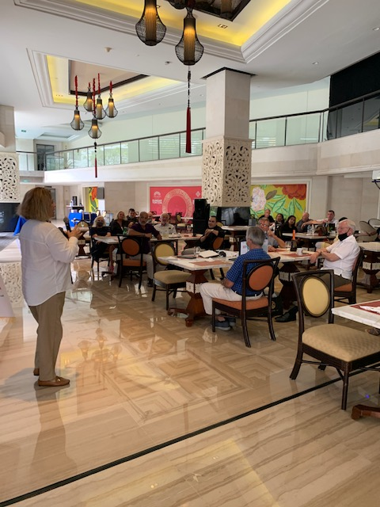
Guest Speaker- RCBS PP/ Sec. Anita Lococo/ Coming to Bali

PP. Anita’s presentation was about her first trip to Bali in April, 1975, and her first impressions of the island at that time. She gave some background about being born in California and traveling after attending University of San Francisco to venture on a round the world trip, leading her to the final destination of Bali. She described her arrival to a small airport and realizing she had come to a rather primitive place with no electricity or modern conveniences. She went into detail about her first experiences in Legian attending the village dances every week and studying Balinese dance in Denpasar. She gave some examples of learning about the culture and mingling with the Balinese and other expats discovering the island’s ceremonies, social structure and avenues of creativity with designing furniture, jewelry and clothing, in those early days of living in Bali. PP Anita lived in Bali for 2 years at that time, leaving a lasting impression on her and prompted her to permanently move here later with her husband in 1991. She presented several early photos of the beach, Kuta and Legian village and herself in her Balinese dancing attire. It was a different time then, a story of another era in Bali.

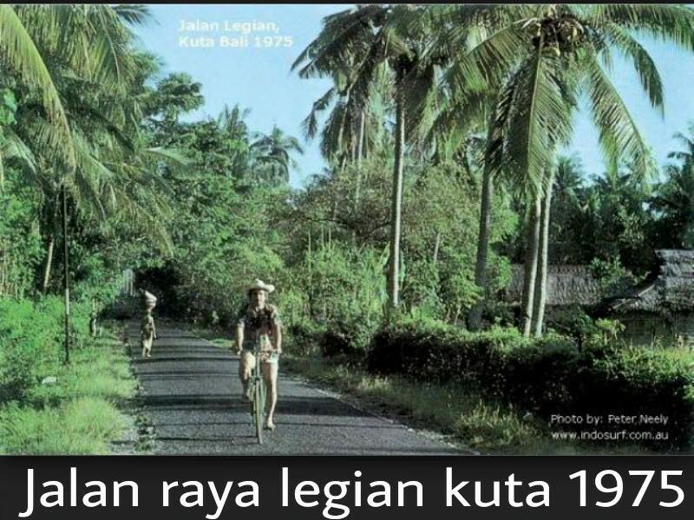

- P. Sarita addressed to the members about the importance of RCBS engaging in Projects, since now we have completed our previous projects. She mentioned doing a project with RC Taman for Cervical Cancer Awareness. P. Sarita encouraged members to introduce project ideas and Global Grant ideas for our club to participate.
- Rtn. Sally and P. Sarita had met on August 4 to brainstorm on some project ideas to pursue. Rtn. Sally then presented some of the ideas discussed at that meeting.
Notes from brainstorming meeting Tues Aug 4 re potential RCBS projects 7/2020-6/2021 & beyond!!

1. School toilets in poorer village in Karangasem

2. New computers, minimum of 2, into schools in remote areas of Karangasem

3. Training programs - Education

4. Contact Rotarian @ RC Tirta Gangga who is active in Karangasem- Pak Latra from Puspadi if the present President.

5. Research villages in Ban area around Mt Agung = very dry & crops limited

6. Look into project late Marlyn Carson worked on in Puhu village, Tista area

7. Pig & housing project in Tista village. District Grant..follow up with AG Erika about costs etc

8. Possible Global Grants = Solar Panels & Wind Turbines for poor remote villages in NE Karangasem where electricity & water are in short supply = sustainability
a) Cost USD50k++
b) Maintenance of battery re solar panels
c) Training must be part of
contract
d) contact Tineke ex RCBS (friend of rotary) who knows solar panel expect for advice
e) challenge will be PLN - need to see how villages can work with PLN...maybe villages can sell their excess supply back to PLN..research needed!!

9. Discussion to be conducted with RC Taman re their cervical cancer small GG project…maybe RCBS can work together to raise more funds!!

10. Look to graduate the library books project of Patrick VK to include E-library programs for older children! Essential to have reading books for younger children to encourage them to enjoy reading!

11. A new area of interest to RI = Environment which would include wild animals & strays = very flexible

12. Discussion/research needed to locate needy villages in Karangasem. SEB will get her staff Made to make contact with Kubu District as his village of Muntigunung is under Kubu & Made knows it well!!

13. SEB will discuss with Made a project she & late Marilyn Carson looked into back un 2015.
Bringing water into Muntigunung primary school where there are toilets but no water to flush toilets or wash hands.

14. Make contact with Honorary Rtn. Daniel Elber, who has a successful cashew & rosella tea factory in NE Karangasem, along with the making of handicrafts.

15. Ask RCBS members to come up with ideas for projects, no matter how small eg “Seeds to Table” like Florian.. work in teams or with friends of rotary.

- Please direct any project ideas to P. Sarita, Chairman of Service Projects, VP Jeni Kardinal or Rtn. Sally.
- Rtn. PP Ray (a Rotary member of RC Perth and Rotarian for 35 years) suggested doing a project with RC Perth, as this club already contributed to the Tista project a few years ago.
- Guest, Rtn. Daryl Mils also suggested doing a project in Timor Leste, since he is familiar with the area.

- Rtn.Manfred, Rotary Guide initiated the raffle, with a bottle of wine, which was won by former RCBS Rotarian, Peter Erni.

Raffle: Rp. 850,000

- P. Sarita reminded members that the next meeting would be on Wednesday, August 19, 2020 at the same location.
The meeting was adjourned at 2 pm.
(Minutes written by Sec. Anita)

