RCBS Meeting Minutes- July 29, 2020

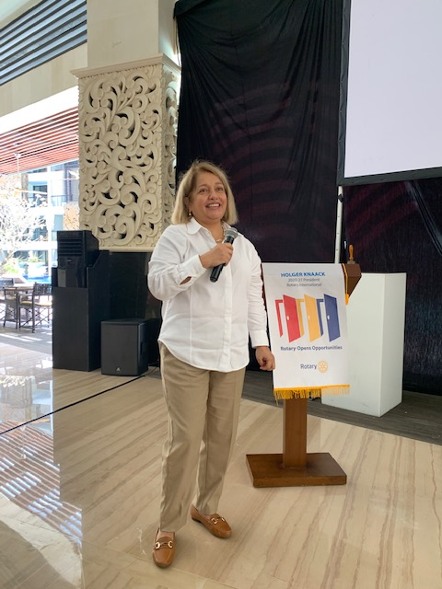
President Sarita

- President Sarita opened the meeting at the Trans Resort poolside restaurant. The members were social distancing at the tables and entered wearing masks.
- The visiting guests introduced themselves:

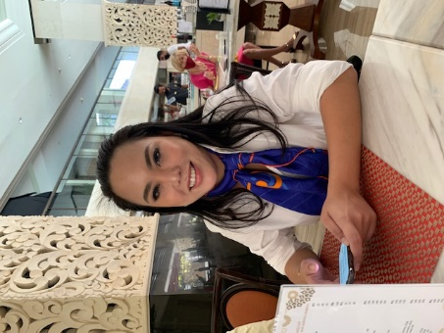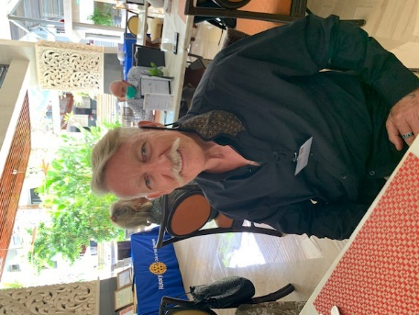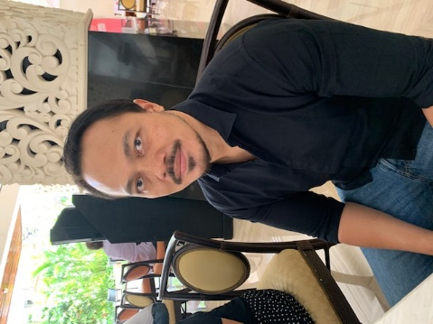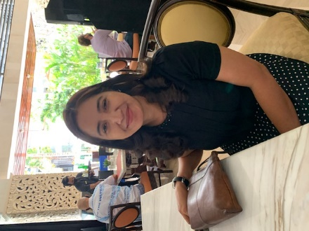
Vickie Charamita Daryl Mills Dr. Made Bhawana Nym. Suwandewi
- The Four-Way Test was recited by PAG Patrick V. K.
- P Sarita (after a delicious lunch) introduced PAG T. Patrick van Kampen, Ph.D. as our guest speaker with some background about him, having been the founder of RCBS as the Charter President, 2002-2003, Club President, 2011-2012, Past Assistant Governor, 2015-2017, Elementary School Library Book program Coordinator, for about 10 years, Rotaract (RAC) Advisor (New Generations Chairperson), and presently the Club’s Executive Secretary, and Chairperson of The Rotary Foundation (TRF) Committee.

GUEST SPEAKER - PAG T. PATRICK VAN KAMPEN, Ph.D.
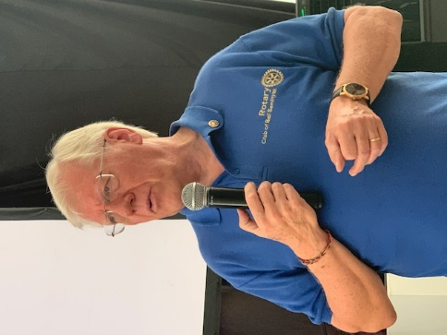
PAG Patrick presented his historical journey of how he came to Bali and became a Rotarian in 1992. PAG Patrick started his professional International School career in 1975 in Milan, Italy. After seven years, in 1981, he ventured, with his PE teacher wife and three-year old daughter, to southern Taiwan to work for International Schools Services (ISS) and managed a small company school (50 students) for Bechtel Corporation. After four very interesting, but isolated years, he and his family moved to Surabaya so that PAG Patrick could become the Headmaster of International School. In 1987 he returned to Michigan, USA to work on his PHD in Education. After receiving his degree in 1989, he took a position as a Deputy Head at a private school in Atlanta, Georgia. Sadly, in 1990 he discovered that his mother had cancer, so he returned to Michigan and took care of her for a year. Thereafter he accepted a position as Director of Curriculum at the of the Jakarta International School. After one year, he decided that working at such a large school (2,000 students), he would look for a smaller one and become the Boss Man. Just by chance in 1991, the Principal of the Bali International School asked PAG Patrick to consider taking his position as he wanted to start his own business in Bali. In 1993, PAG Patrick, with his long-time friend, Ibu Tjok, started the Pranidhana Language School. This school ran successful until the infamous 2002 Bali Bombing. Because the economy in Bali slowed down considerably, PAG Patrick decided to pursue a new business – outside of Bali. He and his business partner at the time, Fuchong Santosa, started exporting Bali Handicrafts to Phoenix, Arizona and San Diego, California. After five years of flying back and forth to the US, PAG Patrick decided to find an easier way to make a living. After being the Club’s 10th President in 2012, he had the opportunity to become the Head of the Yogjakarta International School. However, after less than one year – missing Bali and not seeing eye-to-eye with the chairperson of the Board of Education – PAG Patrick returned to his very quiet home in Ubud. For the next three years he got RE-involved with his East Java’s business partner’s nine SPAs in Ubud, Sanur and Seminyak – as a consultant. Getting restless once again, he accepted another Head of School position in Renon at the Yayasan Doremi SPK schools. This was a big challenge as he was asked to help the school go from an Indonesian national curriculum to a Cambridge International curriculum. After four and one half years, PAG Patrick decided at the age of 68 to retire for a third time.
He finished his talk by explaining his Rotary ‘journey.’ PAG Patrick was first invited to a Rotary meeting in Surabaya in 1985, but at 32 years old he was not ready to join such a ‘senior’ gentleman’s club. However, after arriving in Bali in 1992, the opportunity presented itself once again and he was asked to join the newly chartered RC of Bali Nusa Dua. After nine very enjoyable years with the RCBND, District 3400 asked him to start the first English-speaking club in the Kuta area. The District had determined that quite of few expats lived and worked in the Seminyak area and that this would be a good place to start a club. In May 2002, the RCBS was chartered with 20 members (Secretary Anita, HM Kamal K., Rtn. Dr. Taty and Rtn. Alex P.) and led by founding President, PAG Patrick. 19 years later, he said he was very proud of all the work that the RCBS members have completed over the past years and is looking forwarded to the club’s special 20th anniversary in May 2022.

Lastly, PAG Patrick shared with the members and guests a poem he found some years ago that sums up very nicely why he has remained a PROUD Rotarian for 28 years ……..

Why be (am I) a Rotarian?
It's not for the money,
It's not for the fame,
It's not for any personal gain,

It's just for the love of fellow man (human)
It's just to lend a helping hand,
It's just to give a little of self,

It's to do something you can't buy with wealth,
It's not medals worn with pride,
It's for the feeling deep inside,
It's the reward down in your heart,

It's the feeling you've been part of helping others far and near,
That makes you a Rotarian

by Club Secretary Garry Krischock
RC of Runaway Bay Queensland, Australia
District 9640
http://www.rotaryrunawaybay.org.au/
http://www.rotaryfirst100.org/why

- P. Sarita announced that there will be a meeting next week, Wed. August 5th, with a special guest speaker. Thereafter, the meetings will be every 1st and 3rd Wednesday of each month.
- P. Sarita and Treas. Christian reminded the membership to please pay their membership dues by the end of the month. When payment is transacted, please send proof of payment to P. Sarita or Treas. Christian. Payments should be transferred to:
Rotary Klub of Bali Seminyak
BNI- Bank Negara Indonesia
Account: 975182854

- P. Sarita announced that the “Hung Alleviation” Program, which she has initiated will be delivering 100 boxes of food to Sangglah Hospital for the care workers. Ganesha Restaurant, Gourmet Café and Dijon are supplying the food. If any member wishes to participate in this project, please contact P. Sarita.
- As we begin a new term of Rotary, P. Sarita announced that there are not very many active projects now in RCBS, as last term several were completed. Therefore, members are encouraged to implement project ideas at this time. Presently, RBCS is partnering with RC Taman for a project that would supply medical equipment for cervical cancer patients. Also, another project in Lombok for a hospital has been presented with the need of US$5,000)
- P. Sarita lastly announced and wished a fond farewell for member Rtn. Mario, who was so instrumental in working with projects last term and a real asset to our club will be leaving Bali soon and this will be his last meeting. Thank you, Rtn. Mario for all of your dedicated Rotarian action and service.

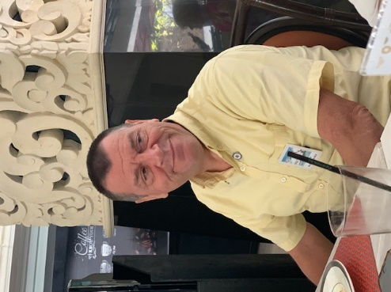
Good-bye Rotarian Mario

The Meeting was adjourned at 2 pm.

(Minutes written by Sec. Anita)

